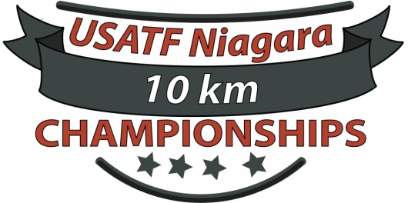
USATF Niagara Open/Masters 10KM Association Championships
2019 USATF Niagara Club Competition Declaration Form
Please Read all of the following
Any Club can declare as many teams as possible
Men can declare 8 score 5, Women & All Masters team can declare 5 and sore 3
Any Club Competing at the 10km Championships must have this submitted no later than 7pm on 5/16/19
Send/Email form to eboycexc@gmail.com
All Scoring Club Teams must be a current 2018 USATF Niagara Club
All Scoring members must be a current 2018 USATF Niagara Member
All Scoring members must have their Club Team Affiliation with the scoring club team that they are scoring for
All Scoring members must be registered to run the race by 7pm on 5/16/19 to be eligible to score for your club.
Official Results and Awards for Club Team winners will be announced at least 24hrs after the race.
Club Name___________________________________________
USATF Niagara Club Number_______________________
Team Captain_____________________ Phone #___________ Email_____________________

Runner Name | Age | Gender | Division | 2019 USATF Niagara Membership Number
Runner Name | Age | Gender | Division | 2019 USATF Niagara Membership Number
Runner Name | Age | Gender | Division | 2018 USATF Niagara Membership Number

